Course |  | EHS5108 | Conduct an Incident Investigation
Term/Year |  | 202120
Program |  | Diploma in Environment, Health and Safety
Assessment Name |  | Assessment 2 |  |  | Date | Start week 8
Student ID Number |  |  |  |  | Block Code | BNDPEHS601 & BNDPEHS501
First Name |  |  |  | Family Name
Student Declaration
I certify that the work presented is my own. It does not contain any material that is subject to copyright or that has been submitted previously for assessment (Unless specifically requested by teacher).
Student Signature |  |  |  |  |  | Date
Elements Assessed
Element 2: Conduct an initial assessment of the situation
2.1 Assess and secure the scene, ensuring that injured parties receive medical attention
2.2 Determine the scope of investigation in accordance with regulatory requirements
2.3 Notify relevant regulatory bodies and management in accordance with requirements
2.4 Determine the resources required for incident investigation
Element 3: Gather incident information for analysis

3.1 Inspect the incident site, equipment, and other evidence
3.2 Collect and document witness statements and equipment logs
3.3 Collect and document photographs, measurements and security camera footage if available
3.4 Collect and review documentary evidence, company procedures and work instructions
PC MATRIX
PC | 2.1 | 2.2 | 2.3 | 2.4 | 3.1 | 3.2 | 3.3 | 3.4
Task 1 | x |  |  |  | x | x | x | x
Task 2 |  | x | x | x

Assessment Instructions
- Assessor: Martin Franks
- Assessment duration: Students will be given time in class to work on assessment. However, additional time for completion of the assessment may be needed outside the class.
- This is a graded assessment which is to be completed 2 students in an investigation team (one group may have 3 students if odd number in class).
- Make sure you complete every task of this assessment. If you are unsure about any of the assessment requirements, please speak to your teacher.
- Use the marking criteria attached to make sure you meet the assessment requirements.
- Copying from other groups is a serious offence and will be dealt with as per ADVETI policies.
- Assessments not submitted by the due date, will not be marked without a completed ‘application form for rescheduled assessment’ (available from the Students Services Centre).
- Assessment documentation must be well organised and filed together when submitted.

Assessment Scenario
- Date: 22/02/2021 Time: 0955 Location: Room B114 Al Jazirah Institute, Al Maqta, Abu Dhabi
- You, as the EHS investigation team respond to the following incident which has just happened at 0955.
- A worker has fallen from a ladder while servicing an air conditioning unit at Al Jazirah Institute.
- There was no supervisor present for the workers
- The co-workers (witnesses) called for security, security called the ambulance and the investigation team (EHS officers)
- The ambulance crew treated the worker for a suspected spinal injury and transported to the hospital (Mediclinic, airport road, Abu Dhabi). Arrival time at hospital was 1030, 20/1/2020
- Injured worker:
- Name: Mohamed Ahmed Khan
- Date of birth: 1/1/ 1990
- Mobile number: 050-401-3233
- EM ID Number: 910-1990-4333212-5
- Address: Room 1 Building 2, Worker camp 1, Zone 15, MBZ City, Abu Dhabi
- Employer/ Contractor: Gold star maintenance services
- Time on job: He is new, just started last month
- Injured Worker statement: “I was reaching too far when servicing a/c unit, then I lost my balance and fell from ladder. I had never been on a ladder before today.”
- Co-worker / Witness 1:
- Sadiq Mohamed
- Mobile number: 050 222 4112
- EMID number: 197-1982-7676543-4
- Date of birth:21/09/1982
- Address: Room 2 Building 2, Worker camp 1, Zone 15, MBZ City, Abu Dhabi
- Witness Statement:
- “I observed Mohamed Ahmed working on the ladder and he was reaching too far over when he lost his balance and fell.”
- Co-worker/ Witness 2:
- Abdul Rahman Abulhaddi
- Mobile number: 050-322-0000
- EMID number: 910-1989-4333212-5
- Date of birth: 02/20/1989
- Address: Room 3 Building 2, Worker camp 1, Zone 15, MBZ City, Abu Dhabi
- Witness Statement; “I observed Mohamed Ahmed working on ladder but did not see the moment when he fell from the ladder, because I was looking into the toolbox”
- Follow up interview at the hospital with injured worker:
- The injured worker was admitted to the hospital with a fractured spine.
- The injured worker is suffering from paralysis from the neck down at the time of this report. It is unknown if the condition is permanent.
- Follow up interview by EHS investigation team at the hospital. The injured worker stated “I am on the job only one month. I had no training on how to use a ladder. I had no supervisor to watch me or to show me how to work on the ladder safely”.
Student Tasks:
The student investigation team will make a report using the:
- Investigation Checklist (attached, complete and write N/A (not applicable) where relevant)
- ADVETI EHS Incident Report Form (attached)
- OSHAD Form G Serious Incident Notification (attached):
Task 1: Assess and secure the scene: (E2 PC1) Describe the scene upon the investigation team’s arrival. Who and what did the investigation team observe? What actions were others taking? What did the investigation team do to secure the scene and provide first aid for the injured worker? (E3 PC2) Take the witness statements. The investigation team documents witness statements in the report. (E3 PC3) Take photographs and measurements get security camera footage. (E3 PC4) Collect company procedures and work instructions (appendix 1).
Task 2: (E2 PC 2) The investigation team completes FORM G, Serious incident notification. (E2 PC 3) The investigation team sends email to Al Jazirah Institute Director to notify of accident on campus (simulate on the word document) (E2 PC4) The investigation team lists on word document the contents of basic investigation kit and phone numbers to the SRA and Al Jazirah Management.

Grading Rubric
Criteria | Distinction  5 marks |  |  | Merit  4 marks |  | Competent  3 marks | Not competent  2 - 0 marks | Comments
Task 1:
Assessed and secured the scene
Take and document the witness statements
Take and document photographs and measurement, gets security camera footage (if available)
Collected company procedures and work instructions
Task 2:
Completed form G (Serious Incident Notification to SRA/ADEK
Documented the email and phone call to AJIST director
Documented the contents of a basic investigation kit and listed phone numbers to the SRA (ADEK) and AJIST director
Total marks out of 35:
5 Outstanding answer including and in excess of everything that is required. |  | 3 Satisfactory answer with only part of the required information.
4 Above average answer including everything that is required. |  | 2 - 0 Answer was not attempted or does not meet course requirements.

Range | Level
90 - 100% | Distinction: Your achievement is outstanding relative to the course requirements.
75 - 89% | Merit: Your achievement is significantly above the course requirements.
60 - 74% | Competent: Your achievement satisfactorily meets course requirements.
0 - 59% | Not Competent: Your achievement does not meet course requirements.
Assessment Result |  | _______/ 100
Teacher’s Feedback and Comments
Student’s Comments
Assessment Event Feedback Acknowledgement
DO NOT SIGN UNTIL YOU RECEIVE THE FEEDBACK
I acknowledge that I have received and understood feedback from my teacher about this assessment event. |  |  | Student’s Signature
 |  |  | Date
I confirm that I have provided feedback about this assessment to this student. |  |  | Teacher’s Signature
 |  |  | Date

Photos of the accident scene, students will submit these photos with the EHS form incident report:
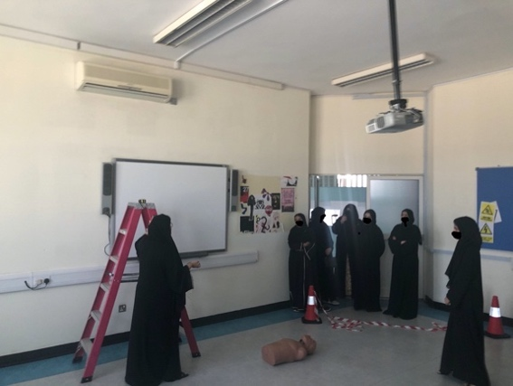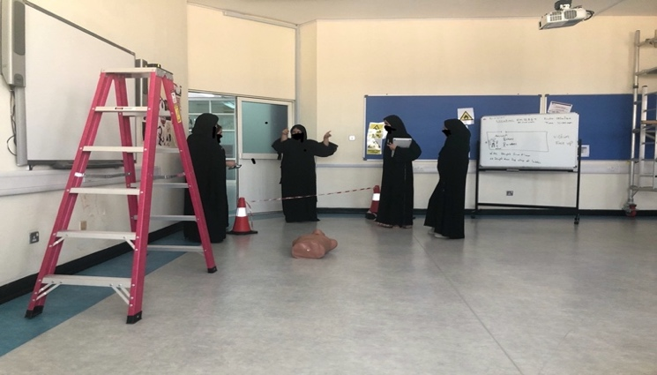
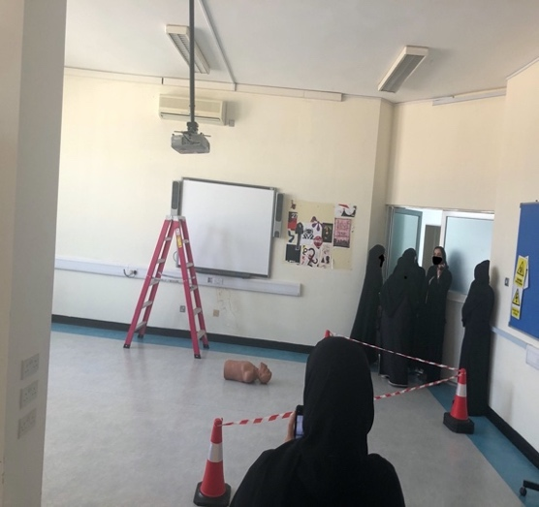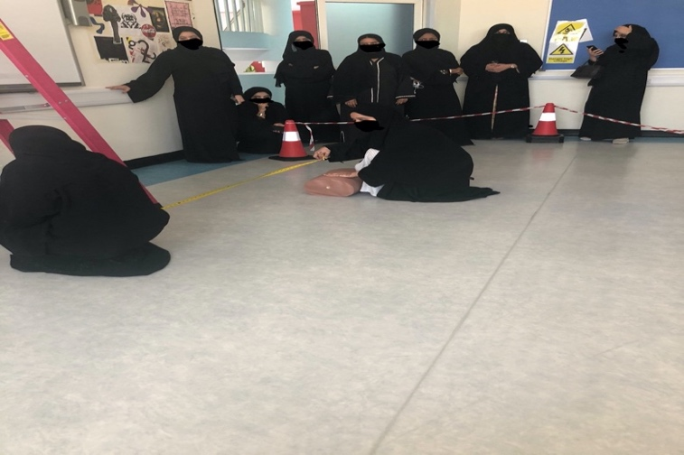
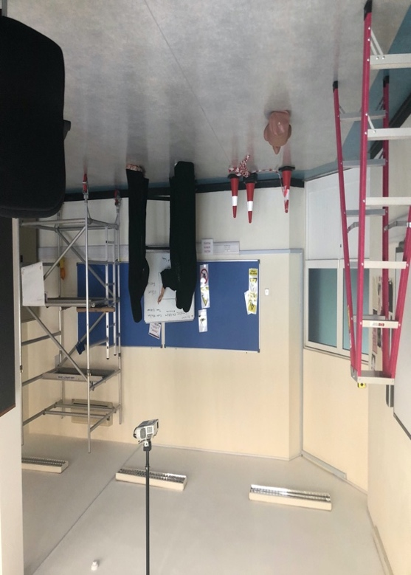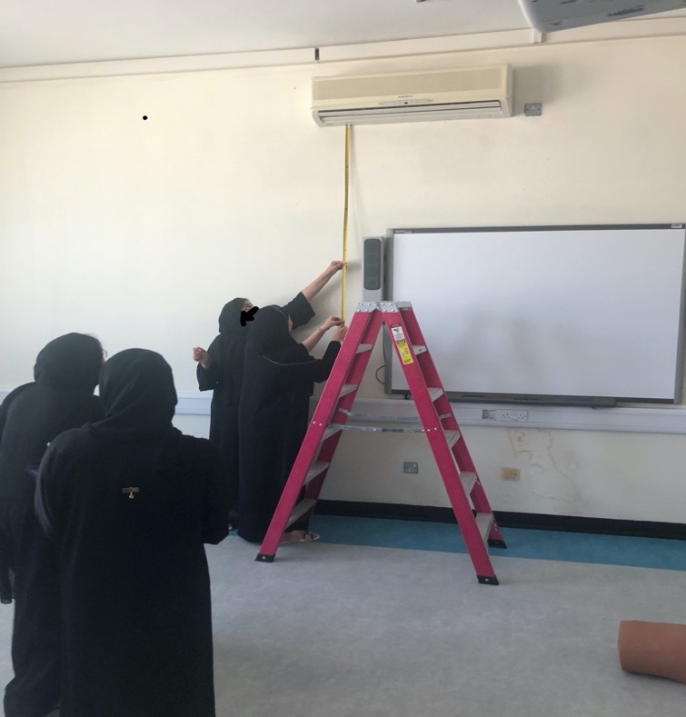

Scene Diagram, students will submit this diagram with the EHS form incident report:
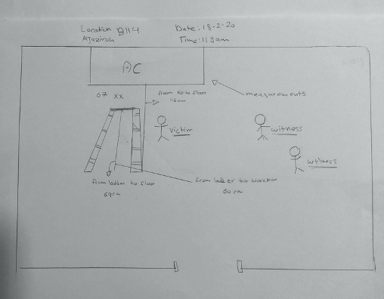

EHS Form |  | 
Document Tittle: | Incident Report:  Accident / Near miss / unsafe condition or practices |  | Sr. No.: | EHS form 10
Document Tittle: |  |  | Campus:
Page 1 of 3 |  |  | Date:
Title of the Accident / near miss / unsafe condition or practices:

Place of the incident :
Building or room number:
Other campus area:
Off campus: _________________________________________________________
Time of incident
Date & Day
Time:
Reported To

Designation:

Names of persons involved in the incident:
Name | Staff / student / contractor / visitor | Mobile no.
Witnesses:
Name | Staff / student / contractor / visitor | Mobile no.

Brief description of the incident

Actions taken at time of incident to minimize the impact of the incident, e.g. removal of guards, emergency procedures, equipment removal, etc.

Reported By:
Name:
Signature:
Mobile No:
Noted and recorded by:
Campus Facilities Coordinator:
Signature & Date:

Instructions: Check ‘yes’ when you have completed the item. If students check “no” then should explain in comments (use “n/a” for non-applicable)

